Intake Form

First Name:____________________________ | Last Name:_____________________________
DOB: _____/_____/_______ Gender (Circle one): Male / Female Preferred Language: __________________
Email: _________________________________________________________________________
Are you currently taking any medications? (Please include regularly used over-the-counter medications)
Medication Name | Dosage and Frequency (i.e. 5mg once a day, etc.)
Do you have any medication allergies?
Medication Name | Reaction | Onset Date | Additional Comments

Social Security #_______-_____-__________ Phone: ______________________ Marital: M S W D
Address:____________________________________ City:___________________ State:______ Zip:___________
Occupation:_____________________________ Employer:____________________________________________

Name of Contact Person:_______________________________ Relationship:__________________________ Address:_________________________________________________ Phone:_______________________
Family Medical Doctor:____________________________________________________
□ I would like to sign up for appointment text alerts. If you have checked the box: You will receive the automated message one hour before your appointment time.

How did you hear about our office? Newspaper Community Event Driving By

Friend/Relative: _______________________________ Other: ______________________________

History of Past and Present Illness
Chief Complaint or purpose of this appointment: ____________________________________________________
Describe in your words your discomfort: ________________________________________________________
Rate your pain (circle one): No Pain – 1 – 2 – 3 – 4 – 5 – 6 – 7 – 8 – 9 – 10 - Severe
Date symptoms appeared or accident happened: ______/______/__________
My symptoms are due to an accident involving: Auto Work Other Explain:_______________________________
Have you ever had the same or a similar condition?  Yes  No If yes, when?_______________________
Days lost from work:_________________ Date of last physical examination: ____/____/________

For office use only
Height: _________ Weight:____________ Pulse:_______ Blood Pressure:______ /______

Please accurately shade the EXACT areas where you are experiencing pain: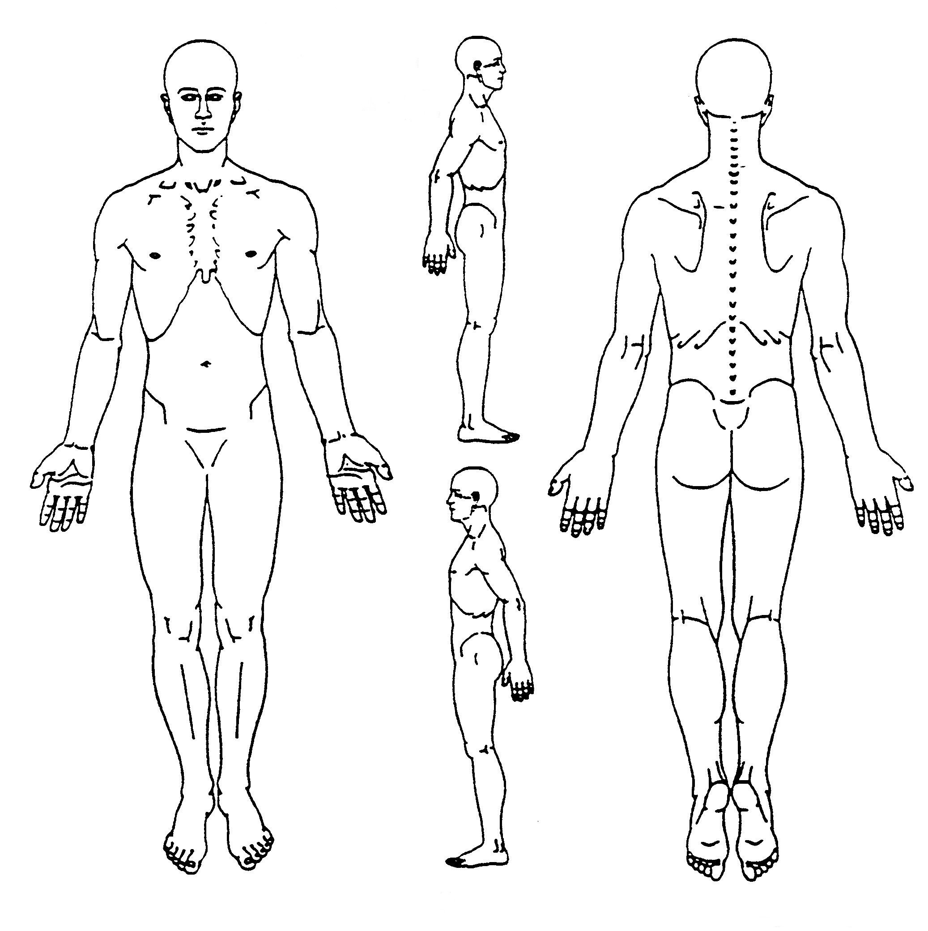
Activities of Daily Living
Check any of the following activities that are affected by your current condition:
Bending | Dressing | Lifting | Standing | Walking
Bathing | Driving | Self-Care | Sleeping | Working
Carrying | Exercising | Sitting | Twisting/Turning | Yard Work
Changing Positions | Household Chores | Climbing Stairs | Concentrating | Lying Down

Have you been treated for any health condition by a physician in the last year? Yes No

If yes, describe:_______________________________________________________________________________

Have you ever received care from a chiropractor before? Yes No

If yes, whom?________________________ Last Seen?______________ What for?_______________
Review of Systems
Please check any of the following symptoms you have experienced in the past year:
Headaches | Neck Pain | Loss of Smell | Dizziness | Blurred Vision
Ringing in Ears |  | Low Back Pain | Loss of Taste | Shooting Pain
Nervousness | Sleeping Problems | Irritability | Mid Back Pain | Sexual Difficulties
Numbness/ Tingling | Tension | High Blood Pressure | Chest Pain | Frequent Urination
Changes in Bowel | Feet Cold | Hand Weakness/ pain | Difficulty Urinating | Fainting
Sinus Problems | Leg Weakness/Pain | Muscle Spasm | Loss of Balance | Fever
Weight changes | Abnormal Menstrual Cycle | Indigestion | Frequent Colds | Joint Swelling
Nausea | Migraines | Fatigue | Joint Pain | Memory Loss
Depression | Trouble Breathing | Excessive Bleeding | Light Sensitivity | Anxiety

Have ever been diagnosed with any of the following conditions?
Osteoarthritis | Osteoporosis | Rheumatoid Arthritis | Immunodepressent | Hypertension
Heart Disease | Cancer | Depression | Anxiety | Seizures / Epilepsy
Circulatory Problems | Low Blood Pressure | Drug Addiction | Alcoholism | Ulcers
HIV | Eating Disorder | Stroke | Pacemaker | Gall Bladder Issues
 Mental Illness |  Asthma |  COPD | Heart Attack | High Cholesterol
 Diabetes |  Thyroid Disorder |  GERD |  Liver Disease |  Anemia
 Kidney Disease |  ADHD |  Disc Herniation |  Gout |  Dementia

Broken Bones and Major Illnesses |  | Surgeries and Hospitalizations
Incident | Year | Incident | Year

Motor Vehicle Accidents |  | Work Place Injuries
Brief Description | Year | Brief Description | Year

Social History
What is the highest level of education you have obtained? 7|8|9|10|11|12|Associate’s|Bachelor’s|Master’s|Doctorate

Do you exercise?  Yes  No Amount per week:______________________
Do you drink alcohol?  Yes  No Amount per week:______________________
Do you use illegal drugs?  Yes  No Amount per week:______________________
Do you consume caffeine?  Yes  No Amount per week:______________________
Smoking Status (Circle one): Every Day Smoker / Occasional Smoker / Former Smoker / Never Smoked

Family History
Has any family member been treated for any of the following? Please indicate their relationship to you.
Father-F Mother-M Sibling-S Child-C
 Heart Disease |  Hypertension |  High Cholesterol |  Asthma |  Tuberculosis
 Gallbladder Disease |  Liver Disease |  Kidney Disease |  Alzheimer’s |  Stroke
 Seizures |  Skin Disease |  Allergies |  Rheumatoid Arthritis |  Osteoarthritis
 Osteoporosis |  Gout |  Anemia |  Diabetes |  COPD
 Lower Back Pain |  Neck Pain |  Disc Problems |  Scoliosis |  Pinched Nerve
 Fibromyalgia |  Cancer  Type:____________ |  Mental Illness  Type:______________ |  Other: |  Other:

FOR WOMEN ONLY:
Are you pregnant or suspect you may be pregnant? Yes No Last menstrual cycle: ____/____/________
# of Live Births: _____ # of Pregnancies: _____ Birth control:____________ Age at Menopause: _____ Date of last mammogram: ____/____/________

I certify the information provided is accurate to the best of my knowledge:

Signature of Patient/Legal Guardian ___________________________________ Date: _______________

Continued Next Page - Agreement of Payment
Agreement of Payment
Please circle any and all insurance coverage that may be applicable in this case:

Major Medical Insurance Medicare Personal Pay Worker's Comp Personal Injury HSA

Name of Primary Insurance Company:___________________________________________________________
Name of Secondary Insurance Company (if any):___________________________________________________

I understand that by being present at this appointment and filling out this admission form that I consent to an exam being administered. I understand that I am responsible for the entire cost of care, unless previously arrangements with the doctor are made in writing or due to a special offer presented. I also understand that if I DO NOT want treatment or therapies suggested by the doctor that I must tell the doctor or staff administering treatment or therapies BEFORE said treatment or therapy is given. I understand that once I have received a treatment or therapy, regardless of my desire to have it, that I will be billed and are financially responsible for treatment or therapy received.
Billing for services will be sent at the beginning of the next month unless otherwise discussed. Payment for services billed is due at the end of the billing cycle (end of billed month) but can be made earlier. If no payment is received by the end of the billing cycle, another bill is sent as a reminder to pay said bill. If no payment is received by the end of the second billing cycle (60 days from initial billing), the account will be deemed negligible and is then eligible to be submitted to collections. The patient is responsible to pay any additional costs or fees that may occur for an account being submitted to a collections agency.
AUTHORIZATION AND RELEASE: I authorize payment of insurance benefits directly to the chiropractor or chiropractic office. I authorize the doctor to release all information necessary to communicate with personal physicians and other healthcare providers and payors and to secure the payment of benefits.

I hereby acknowledge and agree to the terms said above:

Signature of Patient/Legal Guardian _____________________________________ Date _______________

Patient Health Information Consent Form
We want you to know how your Patient Health Information (PHI) is going to be used in this office and your rights concerning those records. Before we will begin any health care operations, we must require you to read and sign this consent form stating that you understand and agree with how your records will be used.
- The patient understands and agrees to allow this chiropractic office to use their Patient Health Information (PHI) for the purpose of treatment, payment, healthcare operations, and coordination of care. As an example, the patient agrees to allow this chiropractic office to submit requested PHI to the Health Insurance Company (or companies) provided to us by the patient for the purpose of payment. Be assured that this office will limit the release of all PHI to the minimum needed for what the insurance companies require for payment.
- The patient has the right to examine and obtain a copy of his or her own health records at any time and request corrections. The patient may request to know what disclosures have been made and submit in writing any further restrictions on the use of their PHI. Our office is obligated to agree to those restrictions only to the extent they coincide with state and federal law.
- A patient's written consent need only be obtained one time for all subsequent care given the patient in this office.
- The patient may provide a written request to revoke consent at any time during care. This would not affect the use of those records for the care given prior to the written request to revoke consent but would apply to any care given after the request has been presented.
- Our office may contact you periodically regarding appointments, treatments, products, services, or charitable work performed by our office. You may choose to opt-out of any marketing or fundraising communications at any time.
- For your security and right to privacy, all staff has been trained in the area of patient record privacy and a privacy official has been designated to enforce those procedures in our office. We have taken all precautions that are known by this office to assure that your records are not readily available to those who do not need them.
- Patients have the right to file a formal complaint with our privacy official and the Secretary of HHS about any possible violations of these policies and procedures without retaliation by this office.
- Our office reserves the right to make changes to this notice and to make the new notice provisions effective for all protected health information that it maintains. You will be provided with a new notice at your next visit following any change.
- This notice is effective on the date stated below.
- If the patient refuses to sign this consent for the purpose of treatment, payment and health care operations, the chiropractic physician has the right to refuse to give care.
I have read and understand how my Patient Health Information will be used and I agree to these policies and procedures:

____________________________________ __________________
Name of Patient Date

The following person(s) have my permission to receive my personal health information, unless listed below my information cannot be released to anyone:

_____________________________________________________________________________________

